ICIMM 2018 FORMATING AND WORD TEMPLATE

Bendit Yadif¹, Islam Mounir², Dina Youcef³, Salah Amrani¹

¹Dresden Technical University, Faculty of Chemistry & Metallurgy, Ilminau, Germany
² Chlef university, Faculty of Engineering, Chlef, Algeria
³………………………………………………
Keywords: Materials, Metallurgy, Metal, Ceramic, Polymer, Composite

Abstract

The extended abstract body should contain abstract, introduction, experimental studies, results and conclusion parts after the set of title, author name(s), affiliation(s) and keywords. The text is in two column formatting after the keyword line.

1. Introduction

The top of the first page of your paper begins with the title of your paper. The title must be 14 pt., bold, centered and in all caps. It is just allowed to use lower-case letters for element abbreviations etc. Author name(s), affiliation(s) and a list of keywords must be followed the title respectively, and they should be 10 pt. and centered. If there is more than one author, the author names are on the same line. Superscript numbers are used for the authors from different affiliations. Each author affiliation should be put on a separate line with a superscript number at the beginning of the related affiliation. Please use at least three keywords. Leave a blank line between title, author name(s), affiliation(s) and keywords, and before beginning the rest of the extended abstract. The typeface of the extended abstract should be Times New Roman, 10 pt. and justified. The extended abstract has to consist of maximum 2 pages.

2. Experimental Procedure

All equations and reactions should be typed flush left and numbered in parentheses at the right-hand margin. Equations separated from the text by one blank line of space above and below.

Ca(CO)3 → CaO + CO2 (1)

First-level subheadings are flush left, bold and numbered (without Abstract, References and Acknowledgment – if desired) and first letter of each word capitalized. All headings should be separated from the text by one blank line of space above and below.
2.1. Second-level subheading

Second-level subheadings are flush left, bold, numbered (such as 1.2., 1.3.) and first letter of each heading capitalized.

Third-level subheading

Third-level subheadings are flush left, underlined and first letter of each heading capitalized.

3. Results and Discussion

Tables and table titles should be prepared in the form given below. A 10 pt. font size is preferred in tables. However, 8 and 9 pt. font sizes are acceptable to fit the data in tables, if necessary.

Table 1. Quantitative analysis result of sample.
Fe | Si | Cu | Mn | Mg
1.02 | 7.54 | 3.45 | 0.36 | 0.32

Figures and figure titles should be prepared in the form given below. Figures should be in a readable quality.

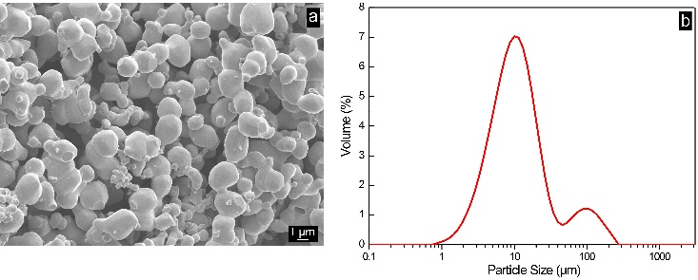
Figure 1. SEM image of the pre-alloyed TZM powder (a), particle size distribution of the powder (b).

4. Conclusion

Please do not add page numbers, because they are going to be added at the time of publishing. Color is acceptable in the manuscript, but if the publication will be in a print volume, all material is going to publish in black and white. Thus, it will be better to prefer black and white colors particularly in figures. SI units must be used in the manuscript. Page size is 215.9 mm x 279.4 mm. Top and bottom margins are 25 mm. Please use 20 mm margin both for left and right side.

References

[1] J. Fan, M. Lu, H. Cheng, J. Tian, and B. Huang, “Effect of alloying elements Ti, Zr on the property and microstructure of molybdenum,” Int J Refract Met H, vol. 27, pp. 78–82, 2009.
[2] H. A. Calderon, G. Kostorz, and G. Ullrich, “Microstructure and plasticity of two molybdenum-base alloys (TZM),” Mater. Sci. Eng., vol. 160, pp. 189–199, 1993.
[3] R. Ohser-wiedemann, C. Weck, U. Martin, A. Müller, and H. J. Seifert, “Spark plasma sintering of TiC particle-reinforced molybdenum composites,” Int J Refract Met H, vol. 32, pp. 1–6, 2012.
[4] S. Majumdar, I. G. Sharma, S. Raveendra, I. Samajdar, and P. Bhargava, “In situ chemical vapour co-deposition of Al and Si to form diffusion coatings on TZM,” Mater. Sci. Eng. A, vol. 492, pp. 211–217, 2008.

[5] ASM Handbook, Properties and Selection: Nonferrous Alloys and Special-Purpose Materials. ASM International, vol. 2, 1992.
[6] <http://www.imtmc.org> Dated: 25.10.2017.

