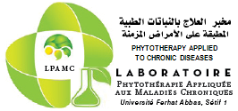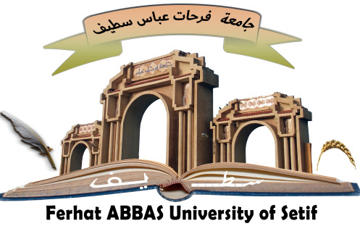

People’s Democratic Republic of Algeria
Ministry of Higher Education and Scientific Research

University of Ferhat ABBAS Setif 1
Faculty of Nature and Life Sciences
Laboratory of Phytotherapy Applied to Chronic Diseases (LPACD)

"National Seminar on Phytotherapy and Pharmacognosy’’
(NSPP-2023)
March 14-15, 2023

Categories | Without accommodation*
Doctorate Student | 3000 DA
Teachers-Researchers | 8000 DA
Companies | 9000 DA
Participation fees

*These fees give the right to documents relating to the seminar, catering and coffee breaks.

Participant Registration Form

Mrs/ Miss/ Mr
First and last names of the participant (First letter in capital)
First and last names of the co-authors
Title of the communication
Establishment/Company
Function and Full Academic Title
E-mail address

Mobile phone (Optional)

Type of communication (Oral / Poster)
Chosen theme (1 to 4)

